A Project Report
on
ONLINE AUCTION SYSTEM

Submitted in partial fulfillment of requirements for the award of the course
of
EGB1201-JAVA PROGRAMMING
Under the guidance of

Mrs.M.Mythili, M.E.,

Assistant Professor / IT

Submitted By

DHANUS VARMA R C (927624BEC035)

DEPARTMENT OF ELECTRONICS AND COMMUNICATION ENGINEERING

M.KUMARASAMY COLLEGE OF ENGINEERING
(Autonomous)
KARUR – 639 113
DECEMBER 2025

M. KUMARASAMY COLLEGE OF ENGINEERING
(Autonomous Institution affiliated to Anna University, Chennai)

KARUR – 639 113

BONAFIDE CERTIFICATE

This is to certify that this project report on “ONLINE AUCTION SYSTEM” is the bonafide work of DHANUS VARMA R C (927624BEC035) who carried out the project work during the academic year 2025 - 2026 under my supervision.

Signature | Signature
Mrs.M.MYTHILI, M.E., | Dr.N. MAHENDRAN, Ph.D.,
SUPERVISOR, | HEAD OF THE DEPARTMENT,
Department of Information Technology, | Department of Electronics and Communication Engineering,
M.Kumarasamy College of Engineering, | M.Kumarasamy College of Engineering,
Thalavapalayam, Karur -639 113. | Thalavapalayam, Karur -639 113.

DEPARTMENT OF ELECTRONICS AND COMMUNICATION ENGINEERING
VISION OF THE INSTITUTION
To emerge as a leader among the top institutions in the field of technical education
MISSION OF THE INSTITUTION
- Produce smart technocrats with empirical knowledge who can surmount the global challenges
- Create a diverse, fully-engaged, learner-centric campus environment to provide quality education to the students
- Maintain mutually beneficial partnerships with our alumni, industry, and Professional associations

DEPARTMENT VISION, MISSION, PEO, PO AND PSO
VISION
To empower the Electronics and Communication Engineering students with emerging technologies, professionalism, innovative research and social responsibility.

MISSION
M1: Attain the academic excellence through innovative teaching learning process, research areas & laboratories and Consultancy projects.
M2: Inculcate the students in problem solving and lifelong learning ability.
M3: Provide entrepreneurial skills and leadership qualities.
M4: Render the technical knowledge and skills of faculty members.

PROGRAM EDUCATIONAL OBJECTIVES (PEOs)
- PEO1: Core Competence: Graduates will have a successful career in academia or industry associated with Electronics and Communication Engineering
- PEO2: Professionalism: Graduates will provide feasible solutions for the challenging problems through comprehensive research and innovation in the allied areas of Electronics and Communication Engineering.
- PEO3: Lifelong Learning: Graduates will contribute to the social needs through lifelong learning, practicing professional ethics and leadership quality.

PROGRAM OUTCOMES (POs)
Engineering students will be able to:
- Engineering knowledge: Apply the knowledge of mathematics, science, engineering fundamentals, and an engineering specialization to the solution of complex engineering problems.
- Problem analysis: Identify, formulate, review research literature, and analyze complex engineering problems reaching substantiated conclusions using first principles of mathematics, natural sciences, and engineering sciences.
- Design/development of solutions: Design solutions for complex engineering problems and design system components or processes that meet the specified needs with appropriate consideration for the public health and safety, and the cultural, societal, and environmental considerations.
- Conduct investigations of complex problems: Use research-based knowledge and research methods including design of experiments, analysis and interpretation of data, and synthesis of the information to provide valid conclusions.
- Modern tool usage: Create, select, and apply appropriate techniques, resources, and modern engineering and IT tools including prediction and modeling to complex engineering activities with an understanding of the limitations.
- The engineer and society: Apply reasoning informed by the contextual knowledge to assess societal, health, safety, legal and cultural issues and the consequent responsibilities relevant to the professional engineering practice.
- Environment and sustainability: Understand the impact of the professional engineering solutions in societal and environmental contexts, and demonstrate the knowledge of, and need for sustainable development.
- Ethics: Apply ethical principles and commit to professional ethics and responsibilities and norms of the engineering practice.
- Individual and team work: Function effectively as an individual, and as a member or leader in diverse teams, and in multidisciplinary settings.
- Communication: Communicate effectively on complex engineering activities with the engineering community and with society at large, such as, being able to comprehend and write effective reports and design documentation, make effective presentations, and give and receive clear instructions.
- Project management and finance: Demonstrate knowledge and understanding of the engineering and management principles and apply these to one’s own work, as a member and leader in a team, to manage projects and in multidisciplinary environments.
- Life-long learning: Recognize the need for, and have the preparation and ability to engage in independent and life-long learning in the broadest context of technological change.

PROGRAM SPECIFIC OUTCOMES (PSOs)
- PSO1: Applying knowledge in various areas, like Electronics, Communications, Signal processing, VLSI, Embedded systems etc., in the design and implementation of Engineering application.
- PSO2: Able to solve complex problems in Electronics and Communication Engineering with analytical and managerial skills either independently or in team using latest hardware and software tools to fulfil the industrial expectations.

ACKNOWLEDGEMENT

We gratefully remember our beloved Founder Chairman, (Late) Thiru. M. Kumarasamy, whose vision and legacy laid the foundation for our education and inspired us to successfully complete this project.
We extend our sincere thanks to Dr. K. Ramakrishnan, Chairman, and Mr. K. R. Charun Kumar, Joint Secretary, for providing excellent infrastructure and continuous support throughout our academic journey.
We are privileged to extend our heartfelt thanks to our respected Principal, B. S. Murugan, B.Tech., M.Tech., Ph.D., for providing us with a conducive environment and constant encouragement to pursue this project work.
We sincerely thank Dr.N.Mahendran M.E.,Ph.D., Professor and Head, Department of Electronics and Communication Engineering, for his continuous support, valuable guidance, and motivation throughout the course of this project.
Our special thanks and deep sense of appreciation go to our Project Supervisor, Mrs.M.Mythili, M.E., Assistant Professor, Department of Information Technology, for her exceptional guidance, continuous supervision, constructive suggestions, and unwavering support, all of which have been instrumental in the successful execution of this project.
We would also like to acknowledge Dr.S.Vimalnath M.E.,Ph.D., Associate Professor, our Class Advisor for his constant encouragement and coordination that contributed to the smooth progress and completion of our project work.
We gratefully thank all the faculty members of the Department of Electronics and Communication Engineering for their timely assistance, valuable insights, and constant support during various phases of the project.
Finally, we extend our profound gratitude to our parents and friends for their encouragement, moral support, and motivation, without which the successful completion of this project would not have been possible.

ABSTRACT

The Online Auction System is a web-based application developed to provide a convenient and automated platform for conducting product auctions digitally. The system enables users to register, log in, browse available items, place bids, and make payments for successfully won products, thereby eliminating the need for physical presence. An administrator module is included to manage auction items, monitor bidding progress, and review payment records, ensuring smooth coordination and system control.The system automatically updates and displays the highest bid in real time, ensuring fairness, transparency, and competitive participation among users. By reducing manual workload and overcoming geographical limitations, the project enhances efficiency, accessibility, and accuracy in auction management. It demonstrates the practical application of Java programming concepts such as classes, objects, encapsulation, and dynamic data handling, while integrating HTML, CSS, and JavaScript for user interaction.This project serves as a simplified model of real-world e-auction platforms and provides scope for future improvements such as database integration, secure authentication, real-time bidding communication, and multi-user networking. Overall, the Online Auction System modernizes traditional auction processes through digital transformation and establishes a reliable foundation for scalable and transparent online commerce

ABSTRACT WITH POs AND PSOs MAPPING

ABSTRACT | COs MAPPED | POs MAPPED | PSOs MAPPED
The Online Auction System is a web-based application developed to provide a convenient and automated platform for conducting product auctions digitally. The system enables users to register, log in, browse available items, place bids, and make payments for successfully won products, thereby eliminating the need for physical presence. An administrator module is included to manage auction items, monitor bidding progress, and review payment records, ensuring smooth coordination and system control.  The system automatically updates and displays the highest bid in real time, ensuring fairness, transparency, and competitive participation among users. By reducing manual workload and overcoming geographical limitations, the project enhances efficiency, accessibility, and accuracy in auction management. It demonstrates the practical application of Java programming concepts such as classes, objects, encapsulation, and dynamic data handling, while integrating HTML, CSS, and JavaScript for user interaction.This project serves as a simplified model of real-world e-auction platforms and provides scope for future improvements such as database integration, secure authentication, real-time bidding communication, and multi-user networking. Overall, the Online Auction System modernizes traditional auction processes through digital transformation and establishes a reliable foundation for scalable and transparent online commerce | CO1  CO2  CO3  CO4  CO5 | PO1  PO2  PO3  PO4  PO5  PO6  PO7  PO8  PO9  PO10  PO11  PO12 | PSO1  PSO2

TABLE OF CONTENTS

CHAPTER  No. | TITLE | PAGE  No.
 | ABSTRACT | IX
1 | INTRODUCTION | 1
 | 1.1 OBJECTIVE | 1
 | 1.2 OOPS CONCEPTS | 2
 | 1.3 LITERATURE SURVEY | 3
2 | PROJECT METHODOLOGY | 5
 | 2.1 PROPOSED WORK | 5
 | 2.2 ARCHITECTURE | 7
3 | MODULE DESCRIPTION | 10
 | 3.1 User Module | 10
 | 3.2 Item Module | 10
 | 3.3 Bidding Module | 11
 | 3.4 Payment Module | 11
 | 3.5 Administrator Module | 11
4 | RESULTS AND DISCUSSION | 12
5 | CONCLUSION | 15
 | REFERENCES | 16
 | APPENDIX | 17

CHAPTER 1

INTRODUCTION

OBJECTIVE

The primary objective of the Online Auction System is to design and implement a fully automated digital platform that modernizes traditional auction procedures and provides users with a convenient, transparent, and efficient way to participate in bidding activities. The system aims to achieve the following goals

Convenience: Enable users to register, log in, browse auction items, place bids, and make payments securely from any location, eliminating the need for physical presence.

Fairness and Transparency: Ensure that the highest bid is automatically updated and displayed in real time, preventing manipulation and human error while maintaining competitive participation.

Administrative Control: Provide an administrator module to add new auction items, manage listings, monitor bidding progress, and verify payment details, thereby ensuring smooth and organized system operations.

Efficiency and Accuracy: Automate bid comparison, payment handling, and record maintenance to reduce manual workload, improve operational speed, and increase reliability.

Accessibility: Overcome geographical and time limitations of traditional auctions by offering a web-based platform accessible to multiple users simultaneously.

Scalability: Establish a strong foundation for future enhancements such as database integration, secure authentication mechanisms, real-time communication, and online payment gateway support.

Educational Value: Demonstrate the practical application of Java programming concepts (classes, objects, encapsulation, inheritance, polymorphism) along with web technologies (HTML, CSS, JavaScript) to build a functional system that reflects real-world e-commerce practices.

OOPS CONCEPTS
Object-Oriented Programming (OOP) is a paradigm in Java that organizes software design around data, or objects, rather than functions and logic. The fundamental concepts of OOP applied in this project are:
1. Classes and Objects
- A class is a blueprint that defines attributes and behaviors.
- An object is an instance of a class that represents a real-world entity.
- Together, they provide structure, modularity, and reusability in programming.
2. Encapsulation
- Encapsulation is the process of binding data and methods into a single unit.
- It restricts direct access to data and ensures controlled interaction through defined interfaces.
- This enhances data security, integrity, and maintainability.
3. Abstraction
- Abstraction focuses on exposing only essential features while hiding implementation details.
- It reduces complexity by allowing users to interact with simplified interfaces.
- This makes systems easier to use and understand without requiring knowledge of internal processes.
4. Inheritance
- Inheritance allows one class to acquire properties and behaviours of another class.
- It promotes code reusability and establishes hierarchical relationships.
- This supports extension of features and reduces redundancy in program design.

5. Polymorphism
- Polymorphism enables a single interface to represent different underlying forms.
- It allows methods or operations to behave differently depending on the context.
- This increases flexibility and adaptability in system design.

LITERATURE SURVEY
Online auction systems have become a common and effective way of buying and selling products over the internet. They represent a digital transformation of traditional auction practices, providing participants with the ability to bid on items without geographical or time restrictions. Many popular e-commerce platforms use auction mechanisms to allow users to compete for products instead of purchasing them at a fixed price. Early online auction models were primarily based on conventional methods such as open-cry auctions, where bids are announced publicly, or sealed-bid auctions, where bids are submitted privately. These models were adapted to web-based interfaces to make them accessible to users from different locations. The initial systems focused on basic features such as user registration, item listing, bidding rules, and winner selection, ensuring transparency and fair competition among bidders.
Several research contributions have provided deeper insights into the design, implementation, and improvement of online auction systems. Bernhard Rumpe (2014) proposed a framework for real-time online auctions using a Java-based client–server architecture. This work emphasized the importance of consistency in bid handling, ensuring that bids are processed correctly and fairly even in dynamic environments with multiple participants. Caminati, Martin, and Prehofer (2013) worked on the verification of combinatorial Vickrey auctions, which are complex auction models involving multiple items and bidders. Their research highlighted the need for mathematical and logical verification techniques to guarantee correctness and fairness of auction outcomes, thereby strengthening trust in digital auction systems. More recently, surveys on secure electronic auction protocols (2022) have highlighted the importance of cryptographic techniques to enhance trust, prevent fraud, and strengthen security in online auction environments. These studies emphasized the role of encryption, digital signatures, and secure communication protocols in protecting user data and ensuring confidentiality of bids.

In addition to academic studies, practical implementations by commercial platforms demonstrate the significance of authentication, bid validation, and secure transaction handling. Large-scale auction websites show how millions of users can participate simultaneously while maintaining fairness and usability. Tutorials and educational resources such as GeeksforGeeks, JavaTpoint, and TutorialsPoint provide simplified models of auction systems, explaining how programming concepts like classes, objects, collections, encapsulation, and event handling can be applied to build functional prototypes. These resources are particularly valuable for students and beginners, offering step-by-step guidance to understand the structure, flow, and components required for building auction applications.
From these studies and references, it is evident that online auction systems must balance fairness, transparency, security, scalability, and usability. The present project builds upon these foundations by implementing a simplified web-based auction platform with essential modules such as user management, item listing, bidding, payment simulation, and administrative control. While designed as an academic prototype, the system reflects real-world practices and provides a strong base for future enhancements such as database in

CHAPTER 2

PROJECT METHODOLOGY

2.1 PROPOSED WORK

The proposed work of the Online Auction System is to design and implement a computerized auction platform that automates traditional auction procedures through a user-friendly and efficient digital interface. The system is intended to provide a convenient environment where users can participate in bidding activities from any location, thereby eliminating the limitations of physical presence and manual handling.

- User Registration and Login The system provides a secure registration process where users can create accounts with unique credentials. Login authentication ensures that only authorized participants can access the auction environment. This functionality establishes identity management, prevents unauthorized access, and maintains the integrity of the system.

- Item Display and Auction Listing Items available for auction are displayed with complete details such as item name, description, and current highest bid. This ensures transparency and allows users to make informed decisions before placing bids. The listing is dynamic, meaning it updates automatically as new items are added or bids are placed, keeping participants fully aware of auction progress.

- Bidding Operations The bidding module allows users to place bids on selected items through an interactive interface. Each new bid is automatically compared with the existing highest bid, and the system updates in real time. This ensures fairness, prevents manipulation, and maintains competitive participation. By automating bid validation, the system reduces human error and guarantees accuracy in determining winners.

- Payment Processing Once an auction is completed, the winning bidder can proceed with payment through a simulated payment module. Transaction details such as item ID, amount, and time are recorded for administrative verification. This ensures completion of the auction cycle and provides a secure and organized way to handle financial transactions within the system.

- Administrator Module The administrator has full control over the system’s operations. This includes adding new items, managing auction listings, monitoring bidding progress, and reviewing payment records. The administrator module ensures smooth coordination, transparency, and accountability in the overall auction process.

Conclusion
Overall, the proposed Online Auction System provides an efficient, transparent, and accessible digital environment for conducting auctions. It modernizes traditional practices by automating core operations and establishes a strong foundation for future commercial deployment.

2.2 ARCHITECTURE
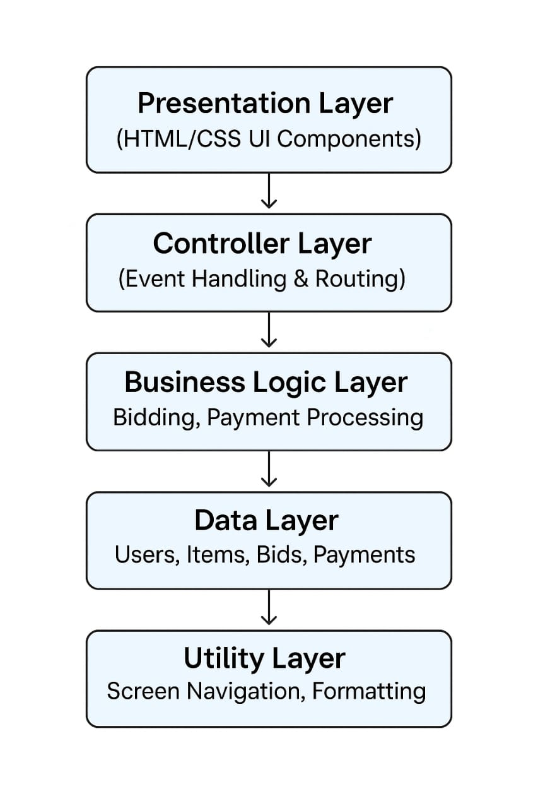

The Online Auction System is designed using a layered architecture to ensure modularity, scalability, and maintainability. Each layer has a specific role and interacts with adjacent layers through well-defined interfaces. This structure allows the system to handle user interactions, business rules, data management, and utility functions in a clean and organized manner.

Presentation Layer
The presentation layer is the topmost layer of the system and is responsible for the user interface. It consists of HTML, CSS, and basic JavaScript components that allow users to interact with the system. This layer displays auction items, bidding forms, payment screens, and user account details in a visually appealing and accessible format. It collects inputs from users, such as login credentials, bid amounts, or payment details, and forwards them to the controller layer for processing. The presentation layer ensures that the system is user-friendly, responsive across devices, and provides clear feedback to users through messages and confirmations.

Controller Layer
The controller layer acts as the bridge between the user interface and the business logic. It receives inputs from the presentation layer, validates them, and routes them to the appropriate business operations. For example, when a user places a bid, the controller checks whether the input is valid and then passes it to the business logic layer for further processing. Similarly, when a user logs in, the controller verifies the credentials before granting access. This layer is mainly responsible for event handling, request routing, and managing the flow of data between layers.

Business Logic Layer
The business logic layer is the core of the system, where all auction rules and operations are defined. It manages bidding procedures, payment workflows, and auction status updates. This layer ensures that bids are valid, payments are processed correctly, and auction outcomes are determined fairly. For example, it checks whether a bid is higher than the current highest bid, verifies that the auction is still active, and updates the system accordingly. By encapsulating all rules and processes, the business logic layer guarantees consistency and reliability in the auction system.

Data Layer
The data layer is responsible for storing and retrieving all system data. It manages entities such as users, items, bids, and payments, ensuring that information is consistent and reliable. This layer interacts with databases to perform operations like adding new users, recording bids, updating item details, and storing payment records. It enforces constraints such as unique user IDs and valid item references, and provides the business logic with efficient queries and durable writes.

Utility Layer
The utility layer provides cross-cutting functions that support other layers. It includes reusable components for screen navigation, data formatting, validation, and logging. For example, it formats bid amounts into currency, validates email addresses during registration, and manages navigation flows such as redirecting users after login or payment. These utilities help maintain consistency across the system and reduce redundancy by centralizing common tasks.

CHAPTER 3
MODULE DESCRIPTION

The Online Auction System is organized into several modules, each designed to handle a specific set of responsibilities. This modular approach ensures clarity, maintainability, and scalability, allowing the system to be easily extended in the future. The following are the major modules and their detailed descriptions

3.1 User Module

The user module manages all activities related to participants of the auction system. It provides functionality for new users to register by entering their personal details and existing users to log in securely. Authentication and authorization mechanisms ensure that only legitimate users can access the system, thereby preventing unauthorized access. Once logged in, users can maintain their profiles, view available auctions, and participate in bidding. This module plays a critical role in establishing trust and security, as it ensures that every action in the system is tied to a verified user identity.

3.2 Item Module

The item module is responsible for managing the products that are available for auction. Administrators can add new items by specifying details such as item name, description, starting bid, and auction duration. Users can browse through the catalog of items, view detailed information, and check the current highest bid. The module ensures transparency by keeping item listings updated in real time, so participants always have accurate information before placing bids. This module essentially acts as the auction catalog, providing the foundation for all bidding activities.

3.3 Bidding Module

The bidding module is the core of the auction system, as it governs the process of placing and validating bids. When a user submits a bid, the module compares it with the current highest bid to ensure fairness and competitiveness. It updates the auction status in real time, reflecting the new highest bid and bidder details. The module also enforces rules such as minimum bid increments and auction deadlines, preventing invalid or late bids. By automating bid validation and updates, this module eliminates human error and ensures that the auction process remains transparent and reliable.

3.4 Payment Module

The payment module handles the financial aspect of the auction once a user wins an item. It provides a simulated payment environment where winners can confirm their purchase. Payment details such as transaction ID, item ID, and amount are recorded for administrative verification. This module ensures that the auction cycle is completed securely and that winners ful fill their obligations. Although the current prototype uses simulated payments, the module is designed to be scalable, allowing integration with real payment gateways in future enhancements.

3.5 Administrator Module

The administrator module provides overall control and management of the system. Administrators can add or remove items, monitor bidding activities, and verify payment records. They are also responsible for resolving disputes, ensuring that auctions run smoothly, and maintaining transparency in the process. This module acts as the backbone of the system, giving administrators the tools to oversee operations and enforce rules. By centralizing control, it ensures accountability and proper governance of the auction platform.

CHAPTER 4
RESULTS AND DISCUSSION

Fig .4.1 online auction system(main menu)

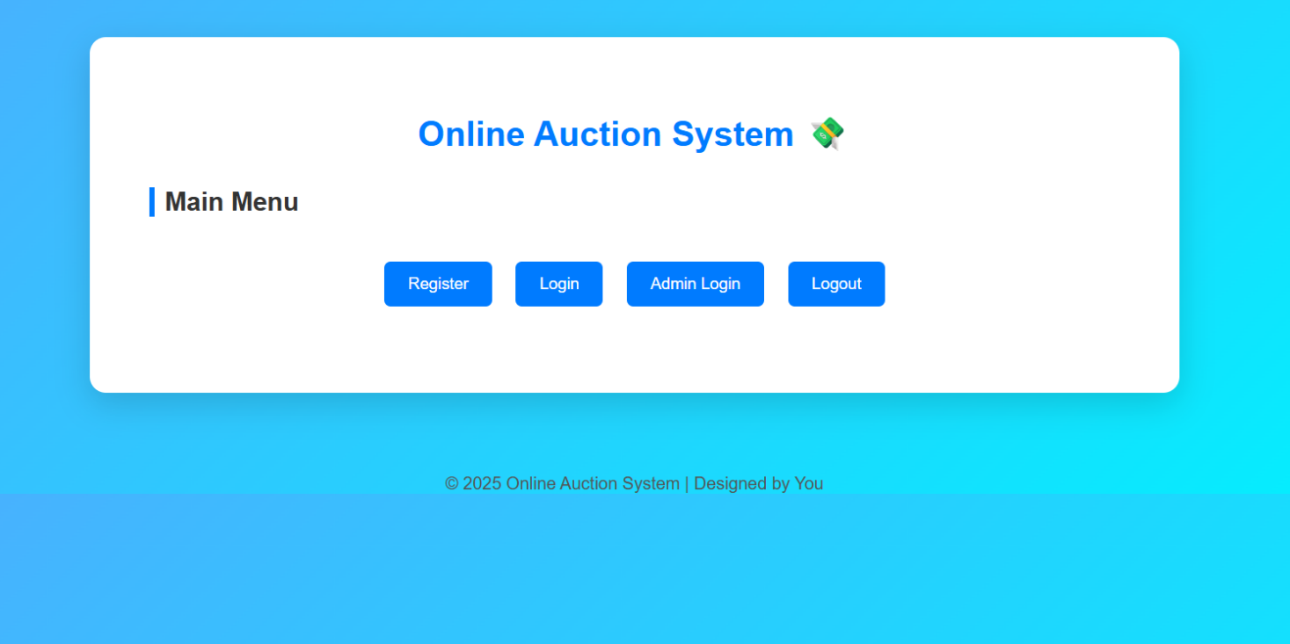

Fig .4.1 Admin dashboard


Fig.4.3 User menu



Fig 4.4 Adding items
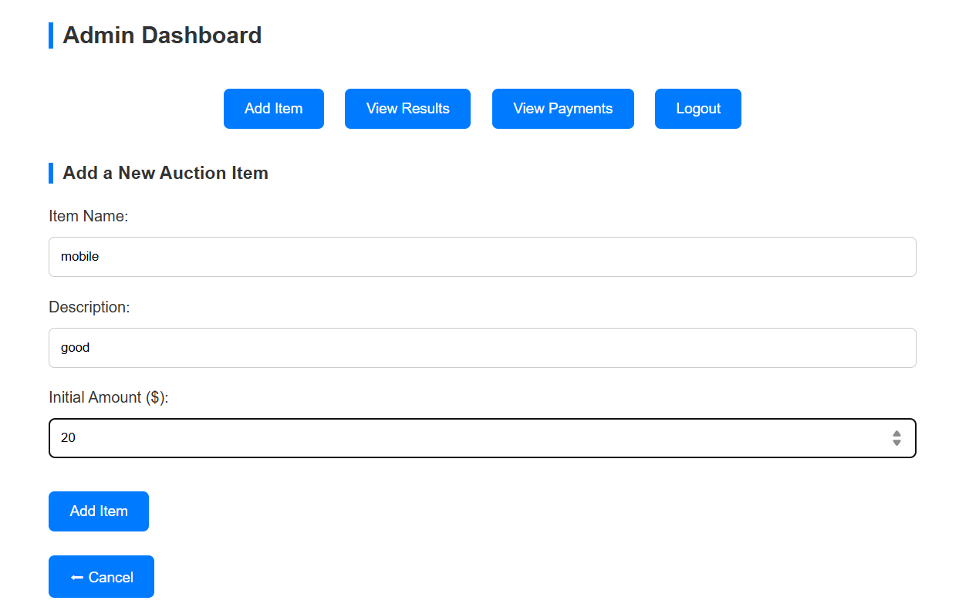

Fig 4.4 Bidding module

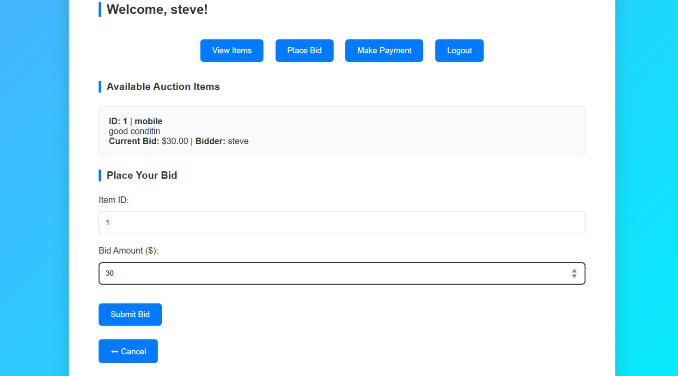

Fig 4.5 Auction result



CHAPTER 5
CONCLUSION

The Online Auction System has been developed as a simplified academic prototype to demonstrate how traditional auction processes can be effectively transformed into a digital environment. By integrating modules such as user management, item listing, bidding, payment simulation, and administrative control, the system ensures transparency, fairness, and usability. The layered architecture provides a structured approach, separating responsibilities across presentation, controller, business logic, data, and utility layers, thereby enhancing scalability and maintainability.
This project highlights the importance of automation in reducing human error, improving accessibility, and ensuring faster and more reliable outcomes compared to manual auction methods. It also reflects real-world practices by incorporating essential features such as authentication, bid validation, and secure transaction handling. While the current implementation focuses on core functionalities, the system has been designed with scalability in mind, allowing future enhancements such as database integration, secure authentication mechanisms, real-time communication, and payment gateway support.

In conclusion, the Online Auction System successfully demonstrates the feasibility of creating a web-based auction platform that balances fairness, transparency, security, and usability. It serves as both a practical learning exercise and a foundation for future commercial deployment, bridging academic concepts with real-world applications.

REFERENCES:

1. Bernhard Rumpe, Framework for Real-Time Online Auctions Using Java-Based Client–Server Architecture, 2014.
2.Caminati, Martin, and Prehofer, Verification of Combinatorial Vickrey Auctions, 2013.
3. Survey on Secure Electronic Auction Protocols, Cryptographic Techniques for Trust and Fraud Prevention in Digital Auctions, 2022.
4. Rohit Mohal, Online Auction Mini Project Report, Academia.edu, 2014 .
5. Online Auction System Project Report – B.Sc. IT 2K17, Studocu, 2023 .
6. Online Auction System – EasyChair Preprint, 2021 .
7. GeeksforGeeks, Auction System Tutorials and Java Implementation Guides.
8. JavaTpoint, Object-Oriented Programming Concepts Applied to Auction Systems.

APPENDIX
(Coding)

<!DOCTYPE html>
<html lang="en">
<head>
<meta charset="UTF-8" />
<meta name="viewport" content="width=device-width, initial-scale=1.0" />
<title>Online Auction System with Payments & Logout</title>

<style>
body {
font-family: "Poppins", sans-serif;
background: linear-gradient(135deg, #4facfe, #00f2fe);
margin: 0;
padding: 0;
color: #333;
}

.container {
max-width: 900px;
margin: 60px auto;
background: white;
border-radius: 15px;
padding: 45px 55px;
box-shadow: 0 10px 30px rgba(0, 0, 0, 0.15);
}

h1 { text-align: center; color: #007bff; margin-bottom: 30px; font-size: 32px; }

h2, h3 {
color: #333;
border-left: 5px solid #007bff;
padding-left: 10px;
margin-bottom: 25px;
margin-top: 25px;
}

button, input[type="submit"] {
padding: 12px 22px;
border: none;
border-radius: 6px;
background: #007bff;
color: white;
font-size: 15px;
cursor: pointer;
transition: 0.3s ease;
margin-top: 12px;
}

button:hover, input[type="submit"]:hover {
background: #0056b3;
transform: scale(1.05);
}

input[type="text"], input[type="password"], input[type="number"] {
width: 100%;
padding: 12px;
border-radius: 6px;
border: 1px solid #ccc;
margin: 12px 0 22px;
box-sizing: border-box;
}

.menu-buttons {
display: flex;
flex-wrap: wrap;
justify-content: center;
gap: 22px;
margin-top: 30px;
margin-bottom: 35px;
}

.back-btn { margin-top: 25px; display: block; }

.auction-item {
background: #f9fafc;
border: 1px solid #e3e3e3;
padding: 18px;
border-radius: 8px;
margin-bottom: 12px;

<label>Password:</label>
<input type="password" id="reg-password" required>
<input type="submit" value="Register">
</form>
<button class="back-btn" onclick="showMainMenu()">⬅ Back</button>
</div>

<!-- Login Form -->
<div id="login-form" class="hidden">
<h2>User Login</h2>
<form id="login-form-data">
<label>Username:</label>
<input type="text" id="log-username" required>
<label>Password:</label>
<input type="password" id="log-password" required>
<input type="submit" value="Login">
</form>
<button class="back-btn" onclick="showMainMenu()">⬅ Back</button>
</div>

<!-- Admin Login -->
<div id="admin-login-form" class="hidden">
<h2>Admin Login</h2>
<form id="admin-login-form-data">
<label>Username:</label>
<input type="text" id="admin-username" required>
<label>Password:</label>
<input type="password" id="admin-password" required>
<input type="submit" value="Login">
</form>
<button class="back-btn" onclick="showMainMenu()">⬅ Back</button>
</div>

<!-- User Menu -->
<div id="user-menu" class="hidden">
<h2 id="user-welcome"></h2>
<div class="menu-buttons">
<button onclick="viewItems('user')">View Items</button>
<button onclick="showPlaceBidForm()">Place Bid</button>
<button onclick="showPaymentForm()">Make Payment</button>
<button onclick="logout()">Logout</button>
</div>
<div id="user-view-items" class="hidden">
<h3>Available Auction Items</h3>
<div id="user-item-list"></div>
</div>
<div id="place-bid-form" class="hidden">
<h3>Place Your Bid</h3>
<form id="bid-form-data">
<label>Item ID:</label>
<input type="number" id="bid-item-id" required min="1">
<label>Bid Amount ($):</label>
<input type="number" id="bid-amount" required min="0.01" step="0.01">
<input type="submit" value="Submit Bid">
</form>
<button class="back-btn" onclick="showUserMenu()">⬅ Cancel</button>
</div>
<div id="payment-form" class="hidden">
<h3>Make a Payment</h3>
<form id="payment-form-data">
<label>Item ID:</label>
<input type="number" id="payment-item-id" required>
<label>Amount ($):</label>
<input type="number" id="payment-amount" required min="0.01" step="0.01">
<label>Card Number:</label>
<input type="text" id="card-number" required placeholder="1234 5678 9012 3456">
<input type="submit" value="Pay Now">
</form>
<button class="back-btn" onclick="showUserMenu()">⬅ Cancel</button>
</div>
</div>

<!-- Admin Menu -->
<div id="admin-menu" class="hidden">
<h2>Admin Dashboard</h2>
<div class="menu-buttons">
<button onclick="showAddItemForm()">Add Item</button>
<button onclick="viewItems('admin')">View Results</button>
<button onclick="viewPayments()">View Payments</button>
<button onclick="logout()">Logout</button>
</div>

<div id="add-item-form" class="hidden">
<h3>Add a New Auction Item</h3>
<form id="add-item-form-data">
<label>Item Name:</label>
<input type="text" id="item-name" required>
<label>Description:</label>
<input type="text" id="item-description" required>
<label>Initial Amount ($):</label>
<input type="number" id="initial-amount" required min="0.01" step="0.01">
<input type="submit" value="Add Item">
</form>
<button class="back-btn" onclick="showAdminMenu()">⬅ Cancel</button>
</div>

<div id="admin-view-results" class="hidden">
<h3>Auction Results</h3>
<div id="admin-result-list"></div>
</div>

<div id="admin-payments" class="hidden">
<h3>User Payments</h3>
<div id="payment-list"></div>
</div>
</div>

</div>

<footer>© 2025 Online Auction System | Designed by You</footer>

<script>
const ADMIN_USERNAME = "admin";
const ADMIN_PASSWORD = "admin123";
let currentUser = null;
let users = {};
let items = [];
let payments = [];
let itemIdCounter = 1;

const msg = document.getElementById("message-area");

function showMessage(text, type = "success") {
msg.textContent = text;
msg.className = `message ${type}`;
msg.style.display = "block";
setTimeout(() => msg.style.display = "none", 3000);
}

function hideAll() {
document.querySelectorAll(".container > div").forEach(div => {
if (div.id !== "message-area") div.classList.add("hidden");
});
}

function showMainMenu() { hideAll(); document.getElementById("main-
highestBidder: "None"
};

items.push(item);

showMessage(`Item "${name}" added with initial amount $${initialAmount}!`);
e.target.reset();
showAdminMenu();
};
hideAll();
document.getElementById("admin-menu").classList.remove("hidden");
const list = document.getElementById("payment-list");
const container = document.getElementById("admin-payments");
container.classList.remove("hidden");
if (payments.length === 0) return (list.innerHTML = "<p>No payments yet.</p>");
list.inner = payments.map(p =>
`<div class='auction-item'>
<b>User:</b> ${p.user}<br>
<b>Item:</b> ${p.itemName} (ID: ${p.itemId})<br>
<b>Amount:</b> $${p.amount.toFixed(2)}<br>
<b>Date:</b> ${p.date}
</div>`
).join("");
}

document.addEventListener("DOMContentLoaded", showMainMenu)</script></body>

